**Bellringer**: Photosynthetic Activity Data Analysis

AP Biology

The effect of temperature on photosynthesis was studied in sweet orange (Citrus sinensis) using leaf discs. The production of oxygen was used to measure the rate of photosynthesis. Gross photosynthesis refers to the sum of net photosynthesis and respiration. Net photosynthesis was calculated by subtracting the rate of respiration in the dark from gross photosynthesis.

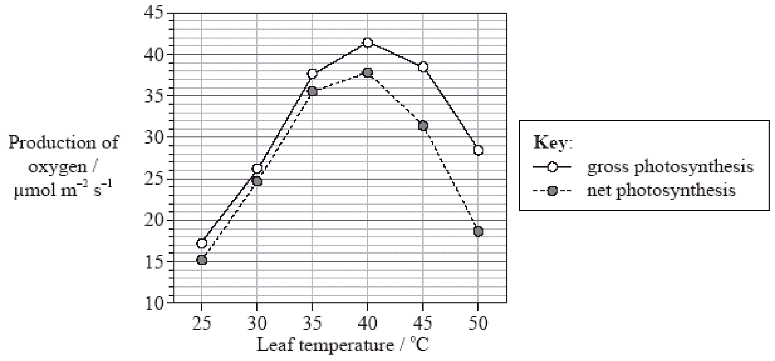

[Source: Adapted from R Ribeiro et al. 2006. *Ciência e Agrotecnologia.* Vol 30. Pp 670–678.]

* 1. Identify the optimum temperature for photosynthesis in this plant. (1)

* 1. Determine the difference between gross photosynthesis and net photosynthesis at 40°C and 50°C. (2)
  2. Deduce what happens to the rate of respiration as the temperature increases between 40°C and 50°C. (1)
  3. Describe the general pattern of change in photosynthesis in sweet orange as the temperature increases. (1)
  4. Compare the effect of temperature on photosynthesis with the effect of temperature on respiration in sweet orange. (2)